# Work Instruction: EZ Metadata Creator – APAC

**Purpose**  
Generate metadata files (Excel and CSV) for environmental restrictions applied to vehicles based on zone, days, time, and vehicle characteristics.  
On the Home page, select the designated zone:

Link: <https://2raxaxqzarwdf6ffwlnacj.streamlit.app/APAC_Zone>

**EZ Metadata Creator - APAC**

**City Identification**  
In this first section, you must enter the exact name of the zone or city, as well as its identifier.

**Vehicle Types**

Here you will find the full list of vehicle categories to which a restriction can be applied. You may select a single option or multiple available options.

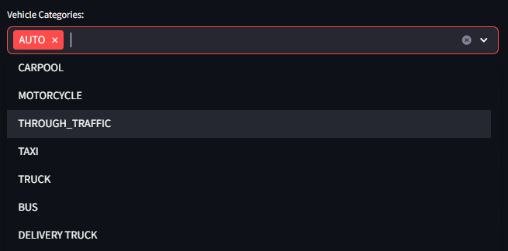

**Restrictions**

This section is essential to indicate the type of restriction that will apply in the metadata.  
The following restriction types are available:

***LICENSE PLATE NUMBER***

For ***Vehicle Restriction***: LICENSE PLATE NUMBERThis option is selected when the restriction is applied based on license plate numbers.

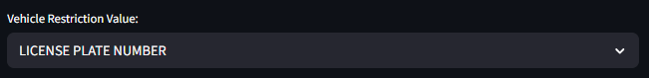

For **EzTag:**  
This field depends directly on the chosen restriction type, as it has different specifications:

* **License Plate**: Applies when the restriction targets general license plates (typically single-digit).
* **License Plate Ending**: Applies when the restriction targets the last digit of the plate.
* **License Plate Starting**: Applies when the restriction targets the first digit of the plate.
* 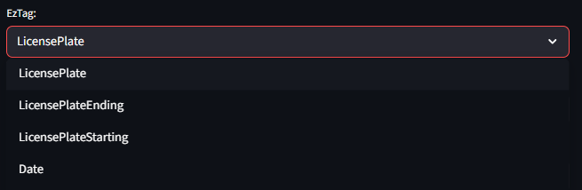**Date**: Applies when the restriction by license plate number depends on a specific date.

For **EzRestriction:**  
This field only applies to the LICENSE PLATE NUMBER restriction. If it appears in other restriction types, please ignore it.

* **LICENSE PLATE**: Applies when the restriction targets specific numeric values.
* **ODD-EVEN**: Applies when the restriction targets odd or even plate numbers.
* **UVVRP**: Applies when the restriction falls under the Unified Vehicular Volume Reduction Program.

***MAX TOTAL WEIGHT***

For ***Vehicle Restriction***: MAX TOTAL WEIGHTSelected when the restriction is based on the maximum allowed vehicle weight for circulation.

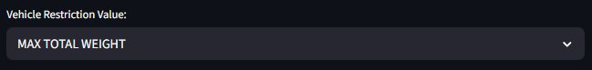  
  
For **EzTag**: Select Max Total Weight  
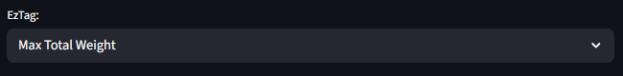

For **EzRestriction**: No action required.

***MIN TOTAL WEIGHT***

For ***Vehicle Restriction***: MIN TOTAL WEIGHTSelected when the restriction is based on the minimum allowed vehicle weight for circulation.  
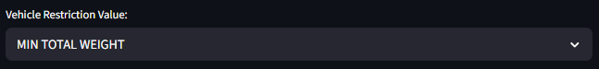

For **EzTag**: Select Min Total Weight  
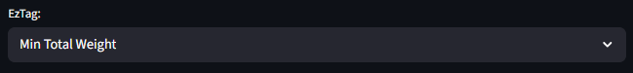

For **EzRestriction**: No action required.

**Start Day / End Day**

Defines the date range during which the restriction applies.  
These dates indicate the starting and ending month and day of enforcement.  
If the restriction applies only by month, use this section as well.

**Example:**  
If the restriction applies from April to September (04–09), only the months are needed.

* **Start Day**: Select any day in April.

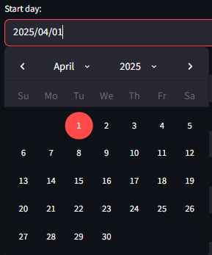

* **End Day**: Select any day in September.  
  A screenshot of a calendar

  AI-generated content may be incorrect.

**Time Range**Indicates the hours during which the restriction is enforced.  
If the restriction does not require a time range, no action is needed in this field.  
If you need to remove this field, delete it directly from the EPAC metadata output.

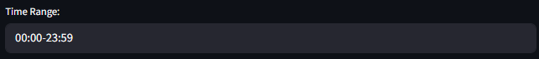

**EZ Description**Write a general description of the restriction.  
If you need additional entries, add them directly in the EPAC metadata output.

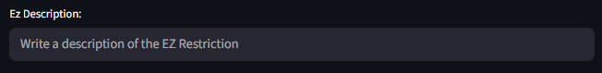

**Lang Description**Indicate the language used for the description.  
If you need additional values, add them directly in the EPAC metadata output.

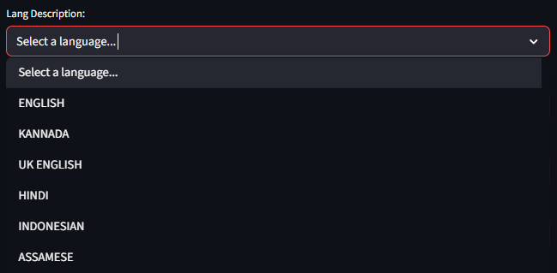

**Website for EZ**Insert the official URL where the restriction information for the EZ zone is published.  
If you need more values, add them directly in the EPAC metadata output.

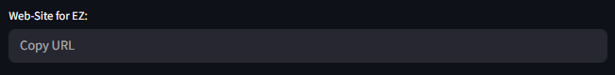

**Days to Apply Restriction**Here you will find all the days available for applying the restriction. You may select from one to all seven days of the week.

**Restriction Values**

**Restriction Values for LICENSE PLATE NUMBER - LICENSE PLATE**  
An input will be displayed with numeric values to indicate the specific license plate numbers that need to be restricted.

**Restriction Values for LICENSE PLATE NUMBER - ODD-EVEN**  
The same input field will appear, where you will find the ODD and EVEN values as needed.

**Restriction Values for LICENSE PLATE NUMBER - UVVRP**  
An input will be shown with a breakdown by day of the week to assign specific license plate numbers to each day. If you do not select a value for a given day, the system will interpret that the restriction does not apply on that day.

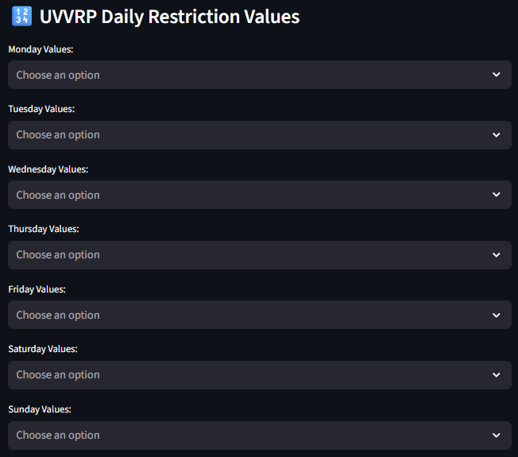

***Example – UVVRP Restriction*:**

Monday: 1-2  
Tuesday: 3-4  
Wednesday: 5-6  
Thursday: 7-8  
Friday: 9-0

*Representation in the application:*

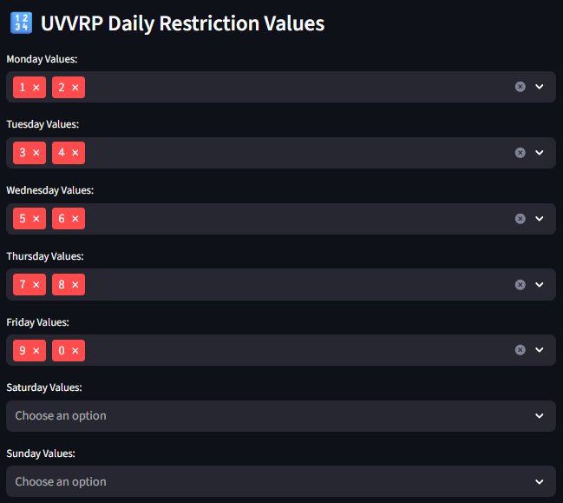

**Restriction Values for MAX/MIN TOTAL WEIGHT**  
An input field will appear where you can enter the weight value. Enter numeric values only.

**Previous Data Display**

This display shows the selected data before generating the metadata. Its purpose is to help verify that the input information is correct.  
Records are generated by vehicle type followed by the indicated date ranges.

To display the data, click the **Generate Records** button. Each time you click this button, the system saves the input values. This allows you to modify the inputs and include different restrictions and values in the same metadata file.

**Example – Combined Restriction: Max Total Weight + License Plate**

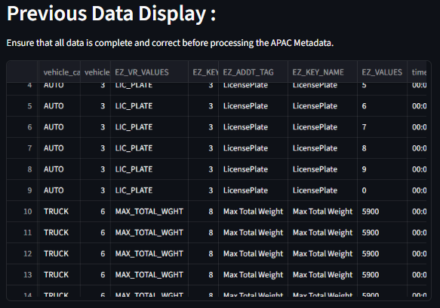

**Metadata APAC**

Once all data is verified in the display, click the **Create APAC Metadata** button.  
This will generate the following sheets:

* **EZ_ADDT_RESTRS_UMRDomainComboRecord**  
  This sheet is generated only for LICENSE PLATE NUMBER restrictions and indicates a record per numeric value.

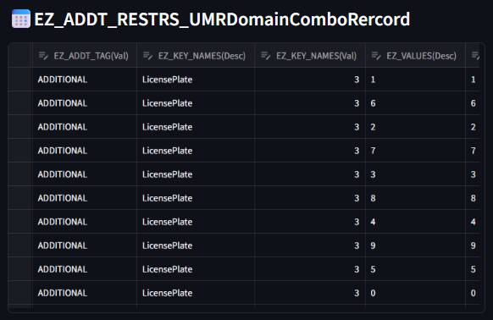

* **EZ_RESTR_UMRDomainComboRecord**  
  This sheet shows the restriction values and the vehicle types to which they apply.

* **EZ_TIME_RESTR_UMRDomainComboRecord**  
  This sheet includes the time-related values of the restriction: hours, dates, days, and months.

* **EZ_VEH_RESTR_UMRDomainComboRecord**  
  This sheet indicates which vehicle types the restriction applies to.

* **EZ_DESCRIPTION_UMRDomainComboRecord**  
  This sheet contains the written description of the restriction and the language used.

* **EZ_WEBSITE_UMRDomainComboRecord**  
  This sheet lists the official source(s) where the restriction information was obtained.

* **EZ_POLYRESTR_UMRDomainComboRecord**  
  This sheet defines the polygonal restriction area, based on the vehicle data.

* **EZ_DATES_UMRDomainComboRecord**  
  This sheet contains the restriction modification dates.  
  ⚠️ *This must be filled manually by the assigned DBE in Excel.*

**For a New City:**

If the metadata is for a newly created city/zone, please select the **"NewCity"** checkbox:



Once selected, the following input fields will appear:

* **Select Country**  
  Choose the country where the new city/zone is located.

* **Select EZ Category Feature**  
  Choose the category type of the environmental zone:
  + **Polygonal Feature**: The restriction applies within a specified polygon.
  + **Linear Feature**: The restriction applies only on selected links.

This will generate the following sheets:

* **ENVZONE_UMRDomainValue**  
  Lists the name-ID record of the new city/zone.

* **ENVZONE_CHAR_UMRDomainCombo**  
  Defines the type of environmental restriction for the new zone.

**Reminder:**  
You can edit any value directly in the generated tables. For bulk modifications, download the file and make changes manually in Excel.

The last button, **“Download APAC Metadata Excel File”**, downloads the APAC Metadata including all the sheets previously mentioned.

**MMT Files Processor**

This section is dedicated to generating the files required to upload into the Metadata Management Tool (MMT).

This tool can be used in two ways:

1. **Use Previous Data**  
   This button requires that the APAC metadata is already created and active within the same application.
2. **Upload External Excel File**  
   This option allows you to upload an external metadata file.  
   It’s useful in cases where manual sorting/editing/deletion was performed in Excel before creating the MMT files.  
   This method works independently and does not require complete metadata.

The tool generates the following files:

* **ADD_EZ_ADDT_RESTRS DataFrame**  
  Generated only if the metadata includes the EZ_ADDT_RESTRS_UMRDomainComboRecord sheet.

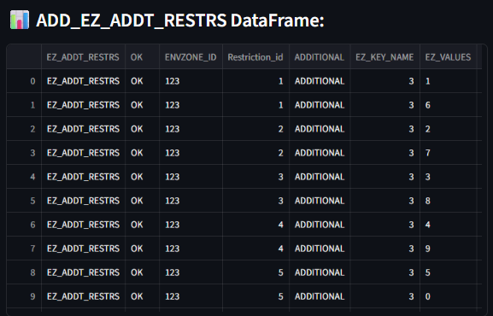

* **ADD_EZ_REST DataFrame**

* **ADD_EZ_TIME_RESTR DataFrame**

At the end, the tool shows three buttons to download each file individually.

⚠️ **Need help?**  
If you have any special requirements or suggestions for improving the tool, feel free to contact the EZ - LDO development team. We’ll gladly get in touch to work on your idea.